Hello,
Welcome to the community infant feeding team. We are a small team that specialises in supporting parents with feeding their baby. We are part of the health visiting team of the 0-19 Service and work closely with them to offer seamless support.
Our team consists of 2 clinical specialists, Carole and Sharon, and our infant feeding support workers, Emma and Jessica.

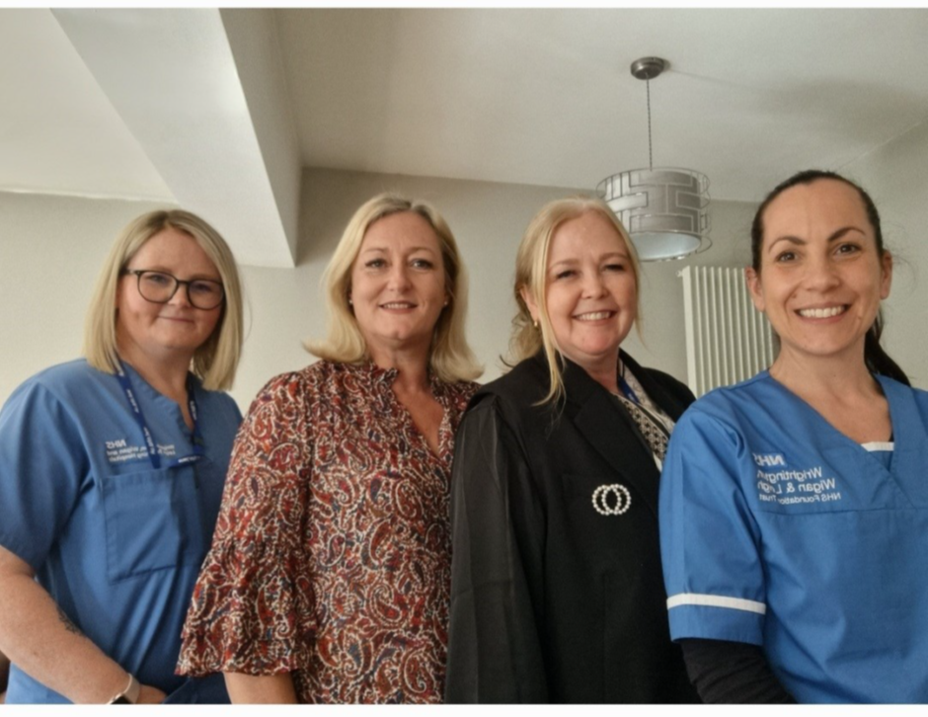

Our support is alongside and in addition to the support you receive from your health visitor and midwifery teams.

When you are home after the birth of your baby, Jess and Emma, can help with common feeding issues encountered by both new and experienced parents with feeding their new baby. It may be that you require more specialised help and support if things don’t improve quickly or are more complex and make a referral to the infant feeding specialists’ clinic with Carole or Sharon.

How to get in touch
As we are out and about visiting families and running our drop- in groups and workshops, our phone is set up for you to leave a voice message with your name and contact number (please speak slowly when reciting your number. We check for messages twice a day Monday - Friday. We aim to call you back as soon as we can but if you haven’t heard from us within 24 hours, please call again as we may not be able to hear your details clearly.
Community Infant Feeding Team Contact Number
0300 707 1172

Our aim is to support parents through pregnancy as well as on arrival home following the birth of your baby and for as long as you need us.
Our antenatal infant feeding workshop is part of the bump, baby and you sessions, and aims to support you in decisions about feeding your baby and helping you prepare for feeding after their birth. During your pregnancy you are always welcome to join us at our breastfeeding drop-in groups and it is a lovely way to meet other parents when you have had your baby.

If you are expecting a baby or breastfeeding you are welcome!
Sessions are facilitated by WWL NHS Community Infant Feeding Team
TUESDAY 9.30-10.30
Atherton Start well Centre
Formby Avenue
M46 0HX

MONDAY 12.45-1.45
Standish Library
Cross Street
WN6 0HQ

